Android Studio Lab Setup
Download Android Studio.
Run the Android Studio.exe
You will see the setup dialogue box.
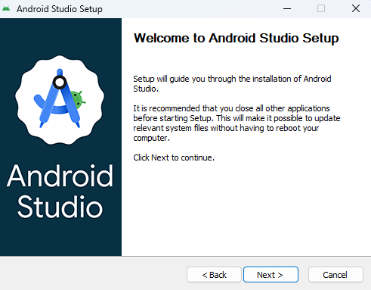
Click on next.
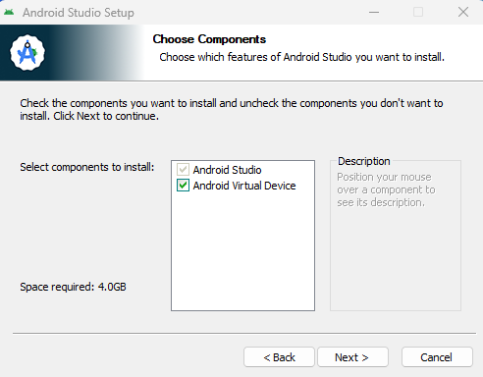
Check the both checkbox and click on next.
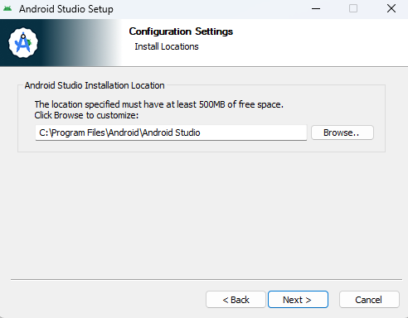
Set the installation path if you want or leave as it is.
Click on next.
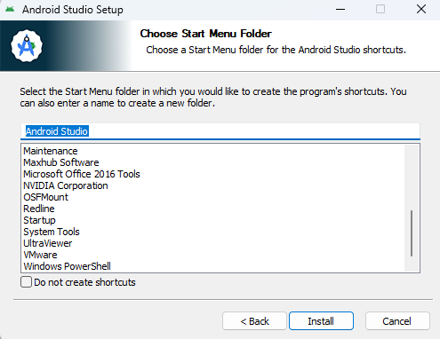
Click on Install.
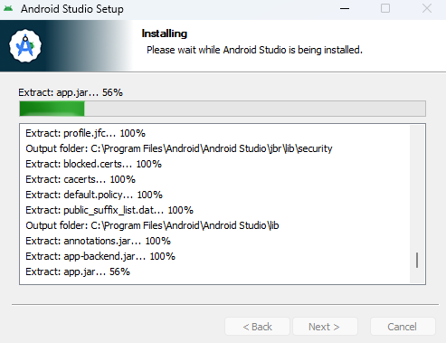
The installation has been stared wait for the completion.
Once it complete click on next.
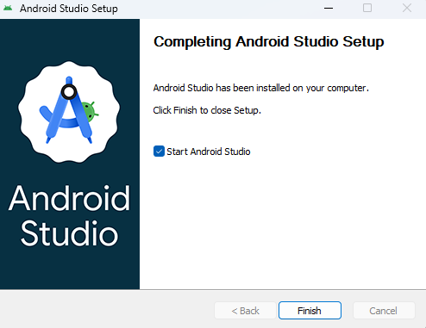
Click on finish.
Due to checkbox checked the Android Studio will automatically starts.
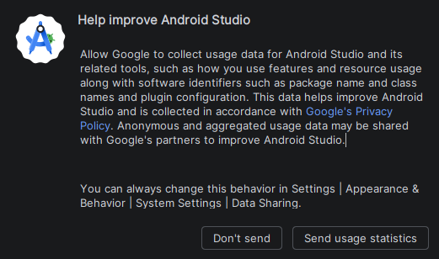
Click on “send usage statistics” if you want to share the usage data.

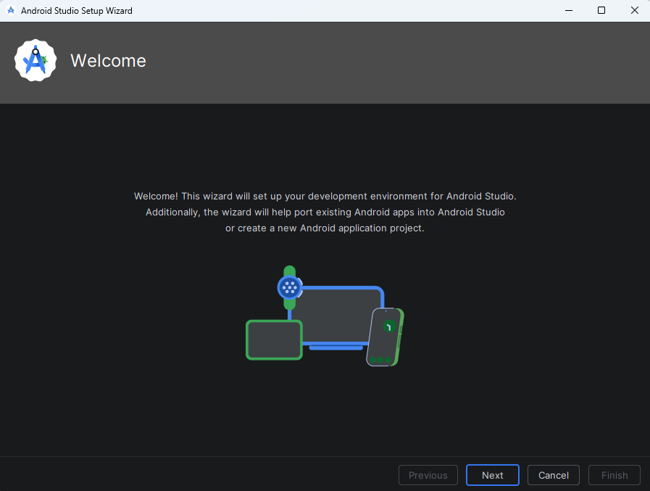
Now click on next.
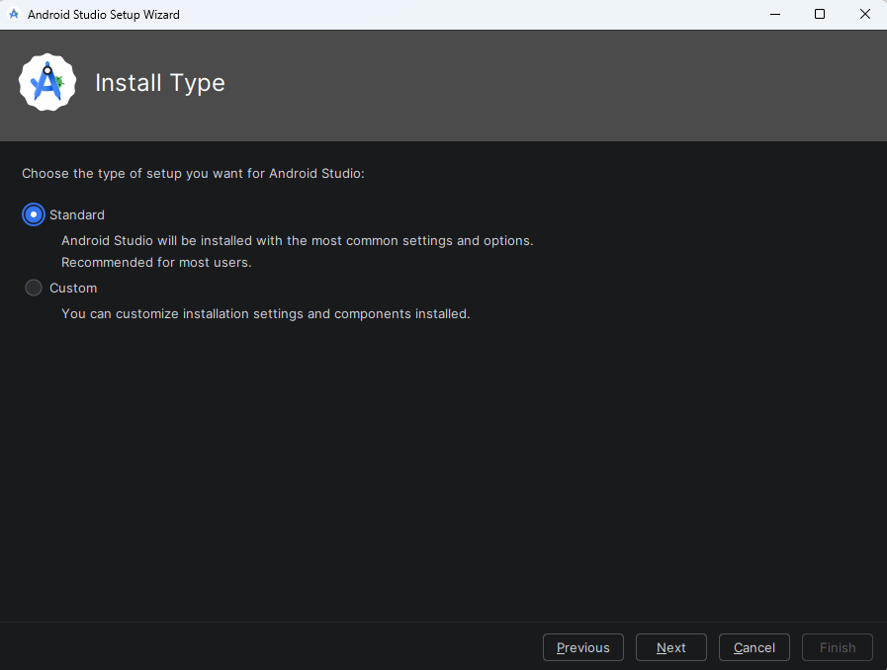
Select the Standard installation and click next.

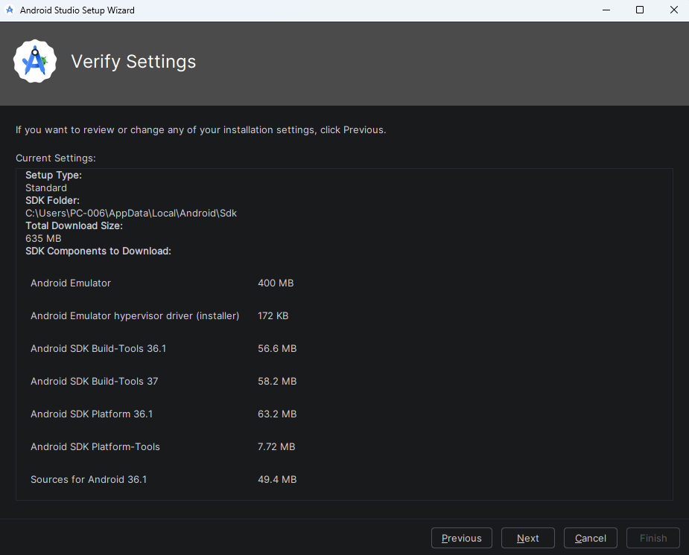
Given Dialogue box says that the listed components are downloaded at the SDK folder path.
Click on next.
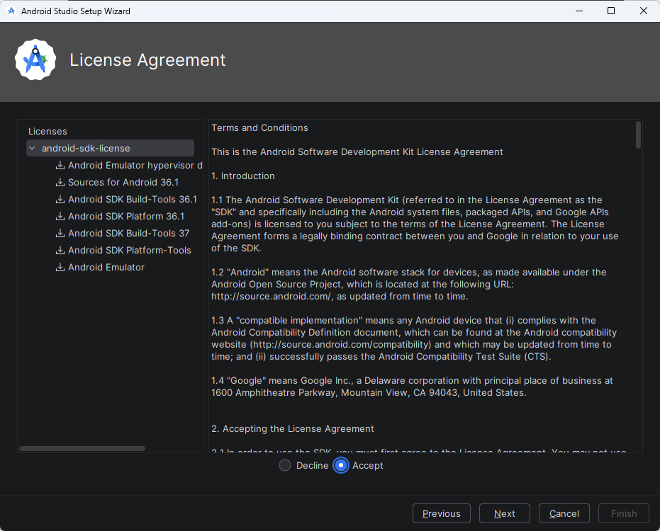
Now on left side the components are listed and on the right side the Terms and Conditions are there read it and select Accept Radio button.
Click on next.
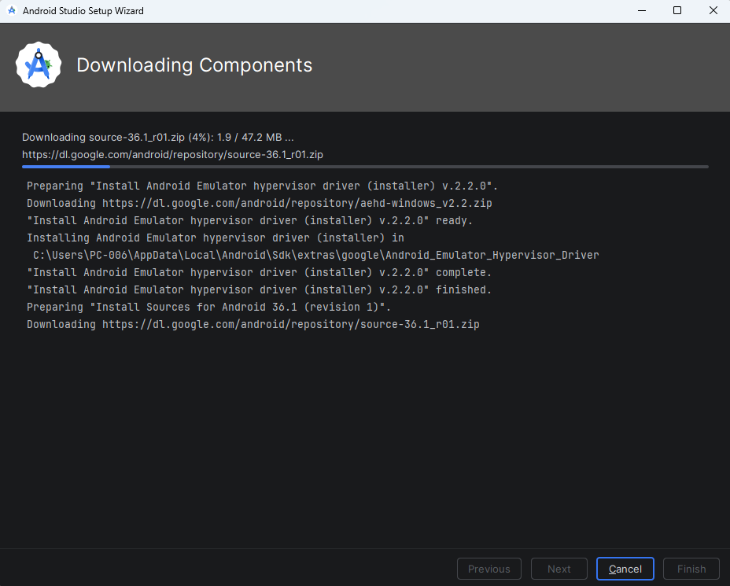
The given process is for downloading the components.
Once it completed click on finish.
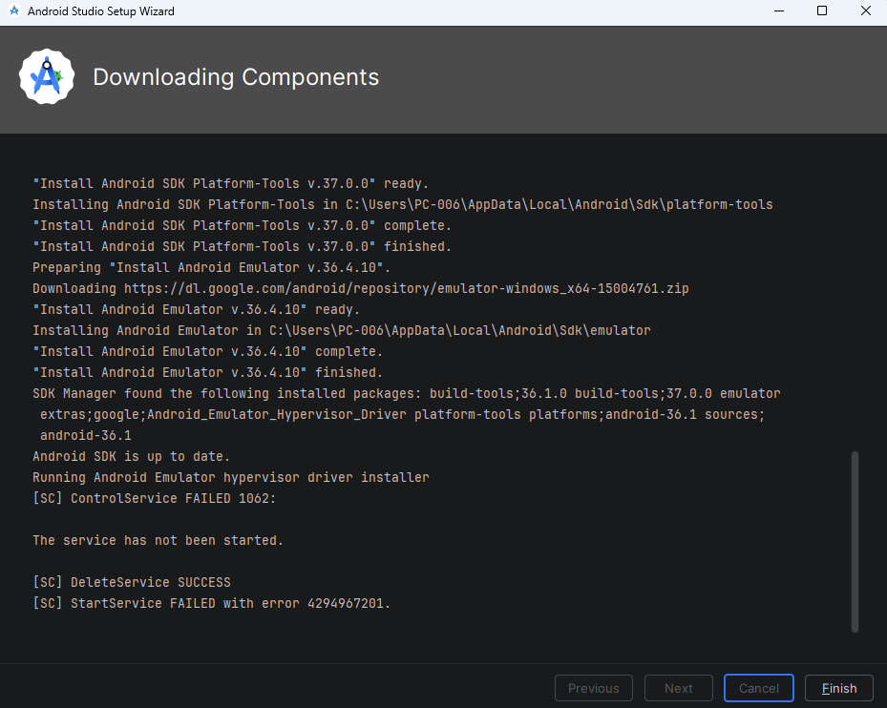
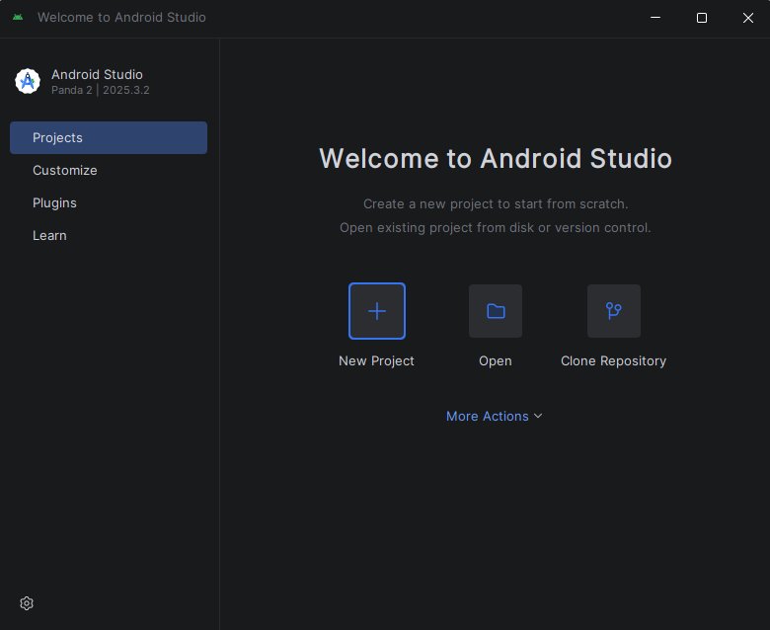
Now click on New Project.
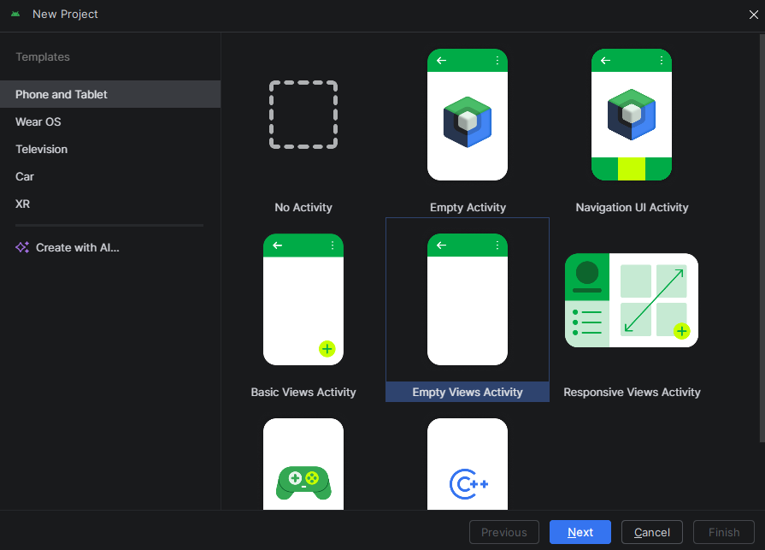
Select the device and also select the Activity and click on next.
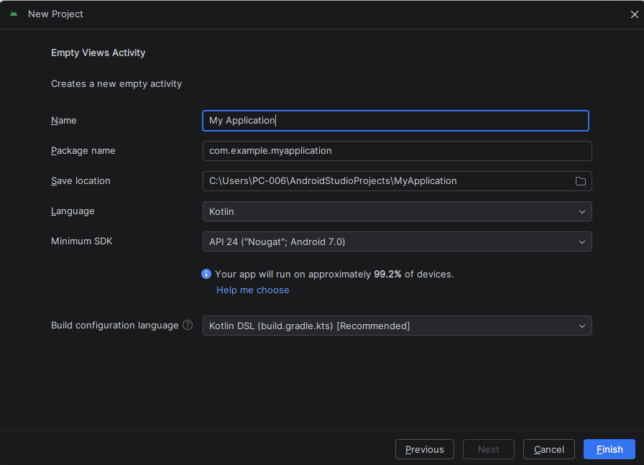
In this give the name of your application.
Give the package name if you want but best practice is leave as it is.
Select the project location.
Select the language Kotlin or java.
Select the minimum SDK which lists all the versions of android’s.
Leave as it is the build configuration language.
Click on finish.
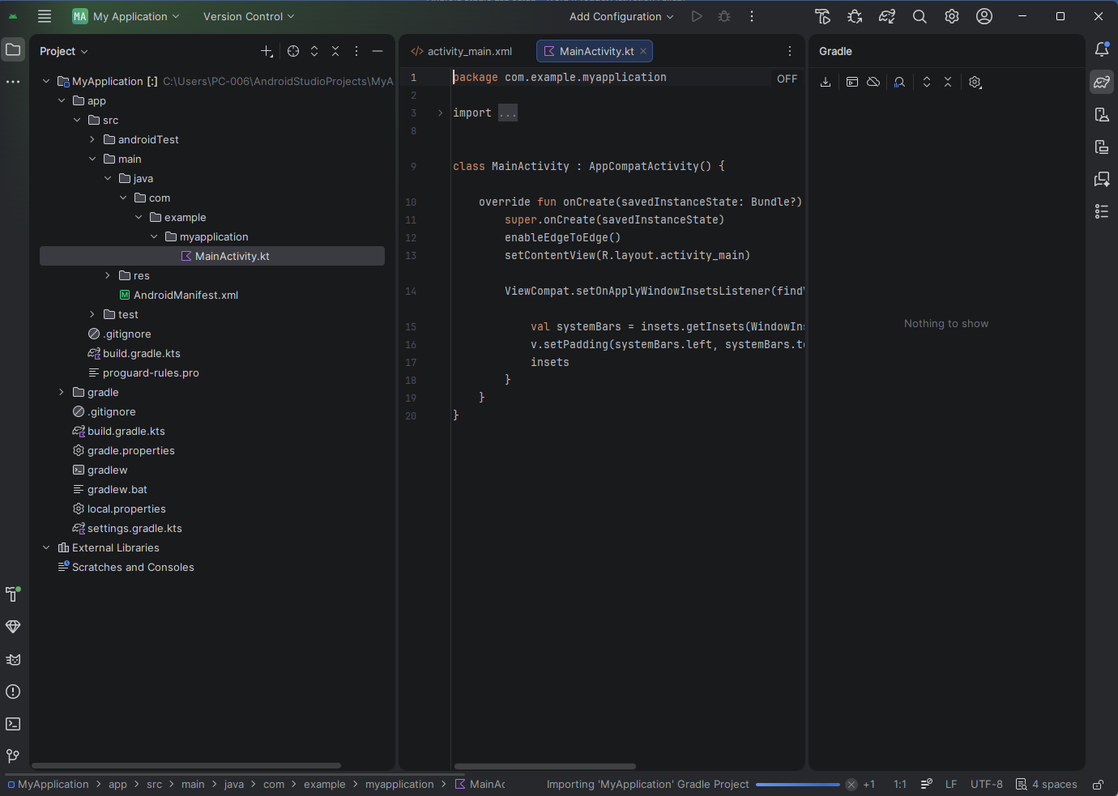

Setup the AVD
Select the Device Manager
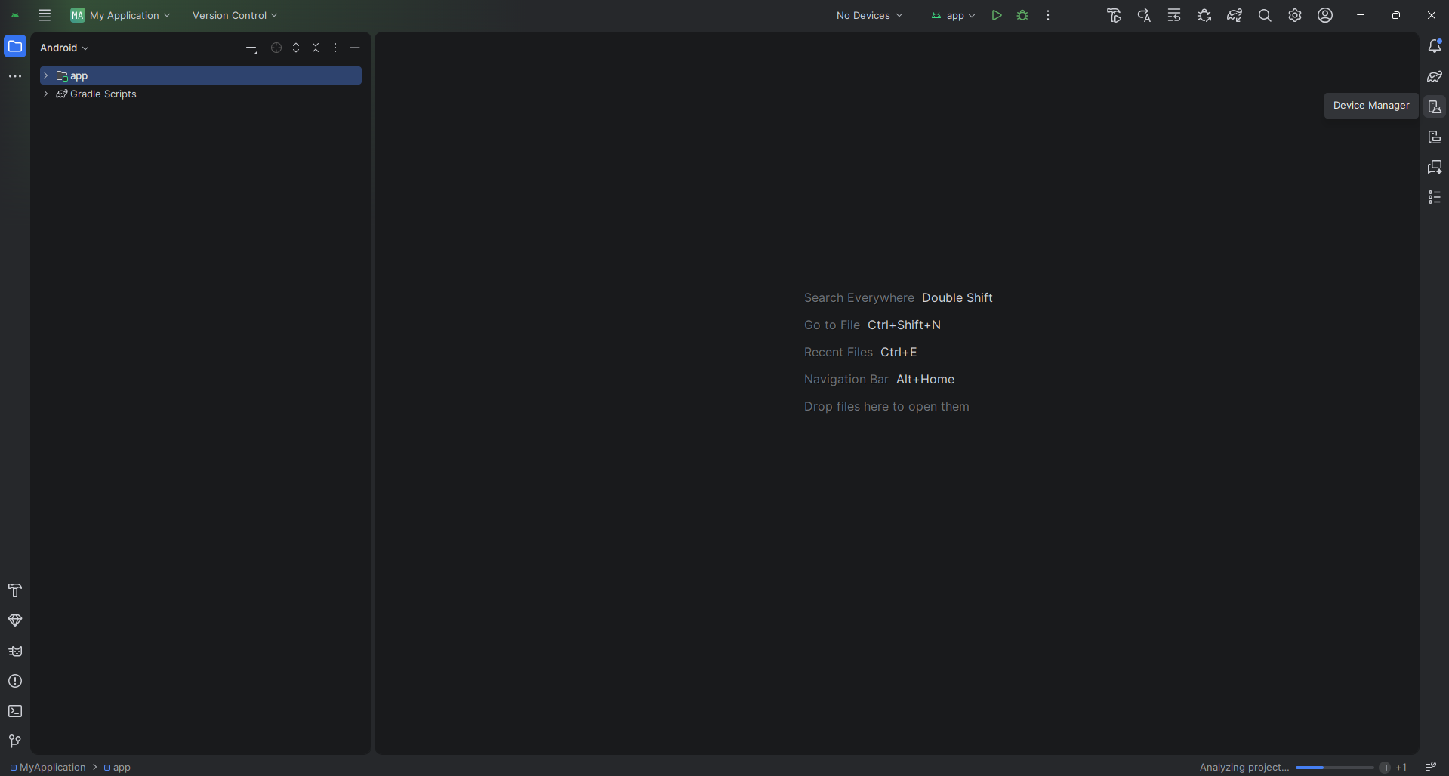

Click on Add a new device.
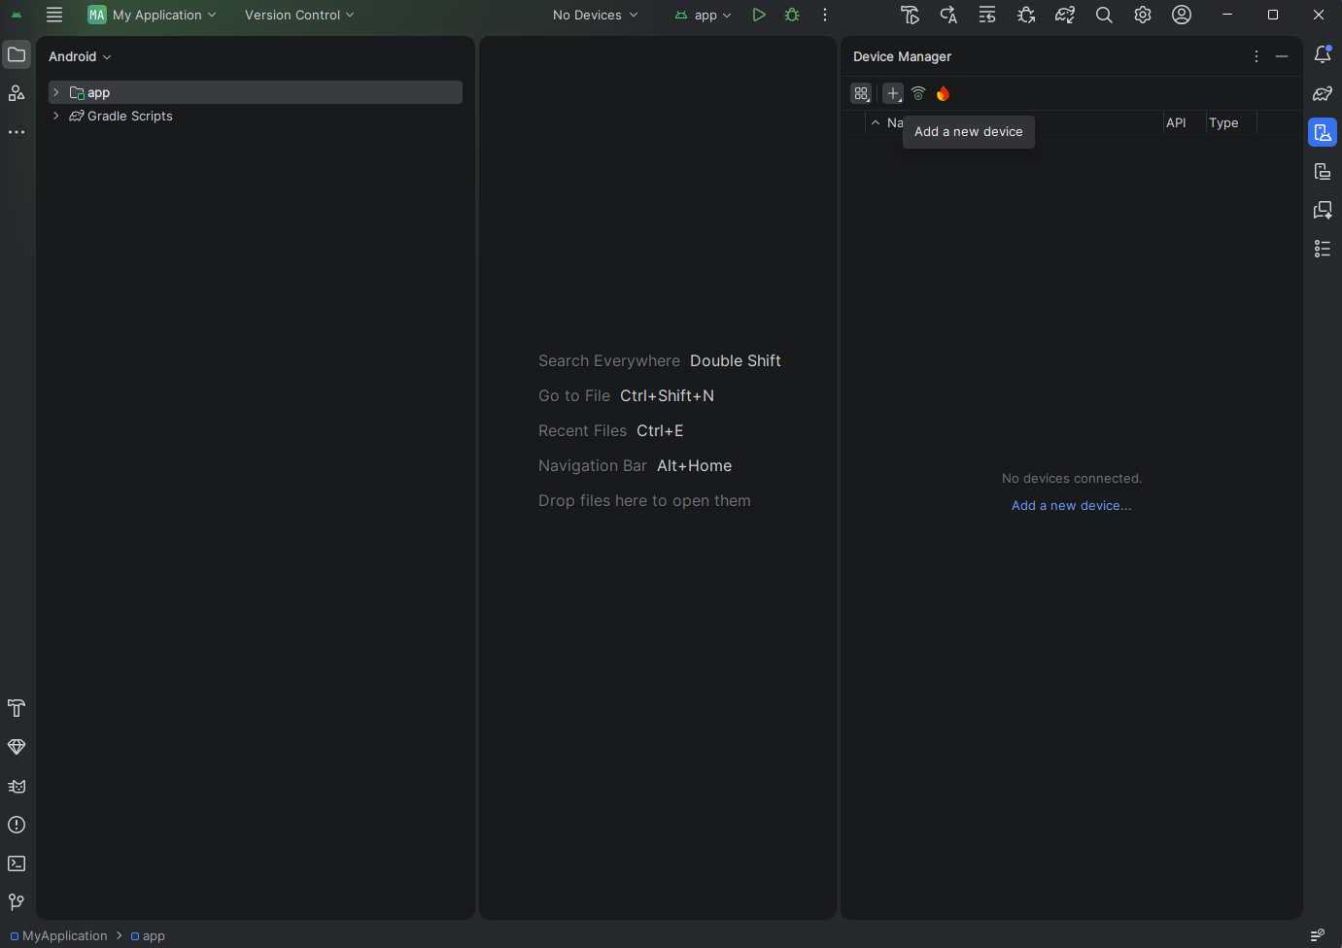
Click on Create Virtual Device.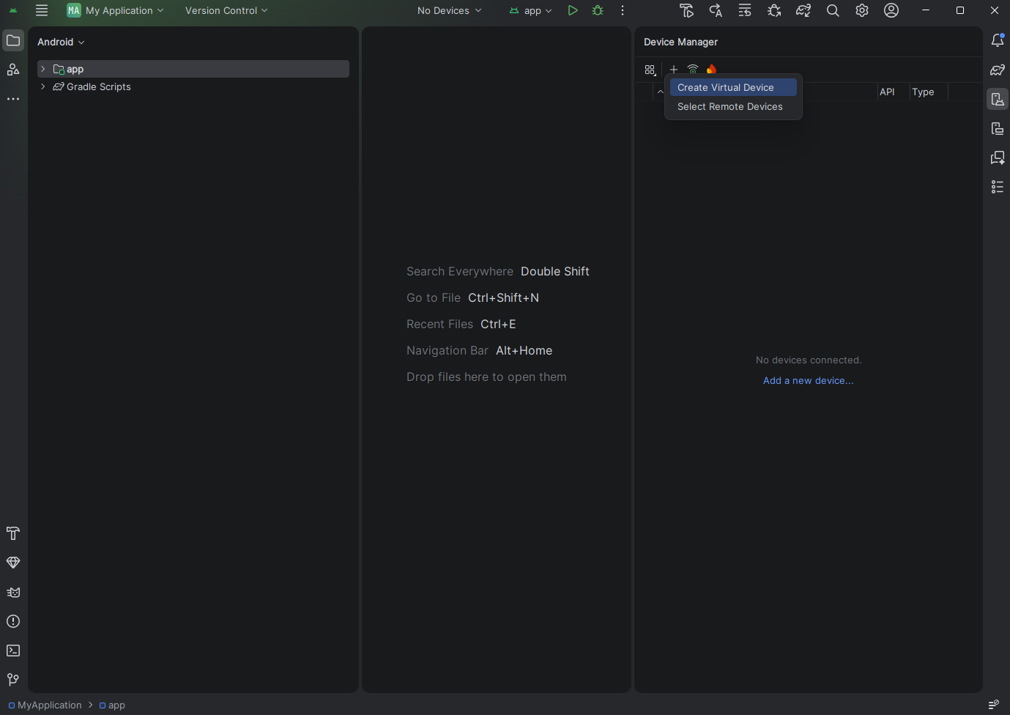
Select the device as you want. (For Ex. Medium Phone)
Click on next.
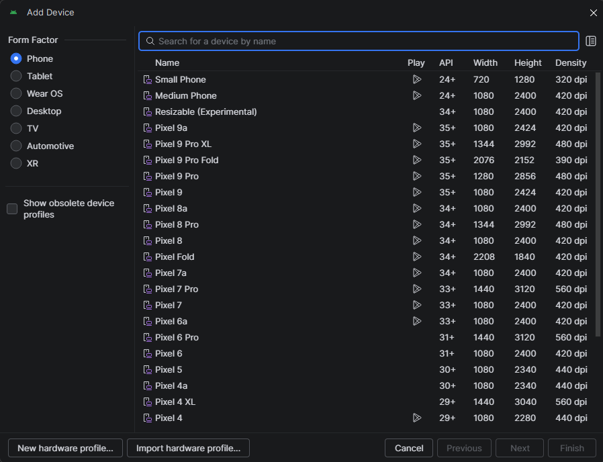
Give the name of your device.
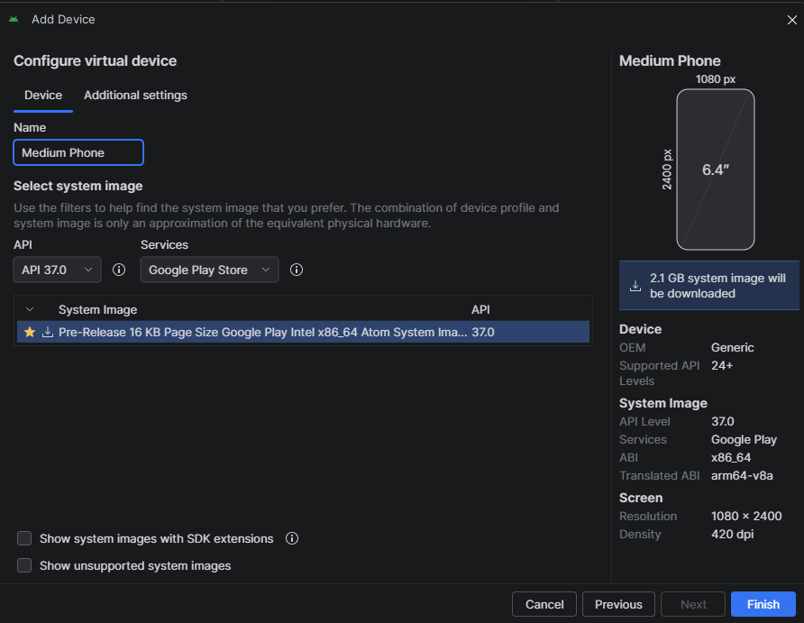
And set the configuration you want (For Ex. API 27 “Oreo”;Andorid 8.1)
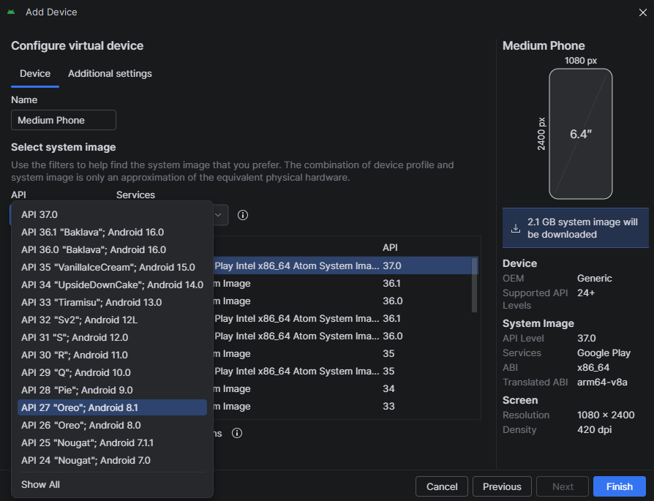
And in Services Select Google APIS.
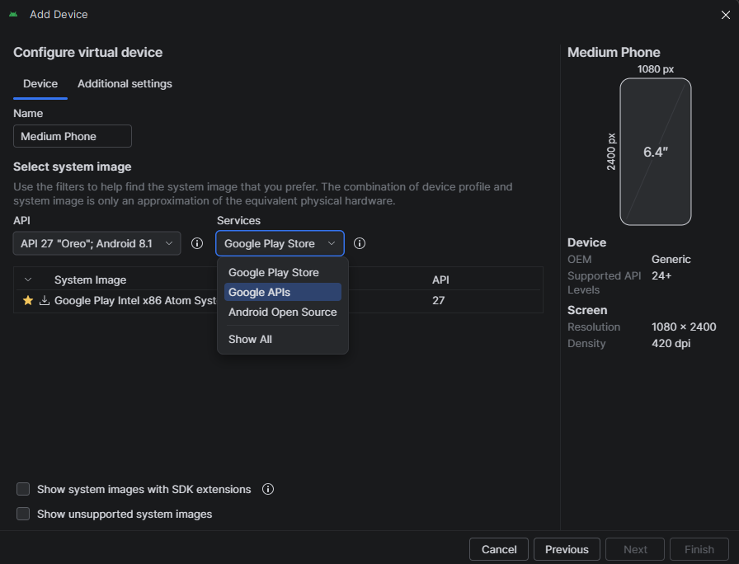
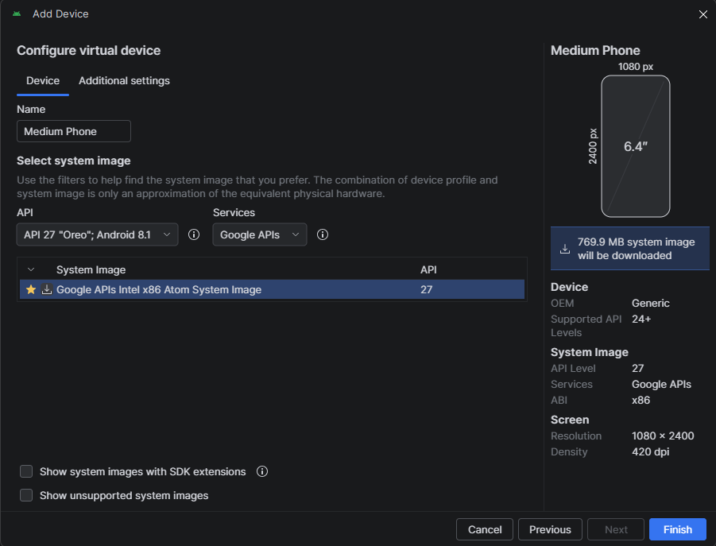
Click on Finish.
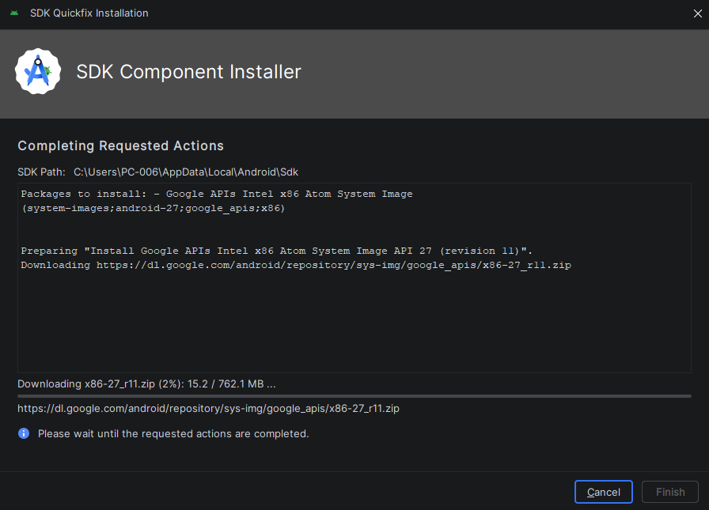
This will downloads required files and all.
Once it completed click on finish.
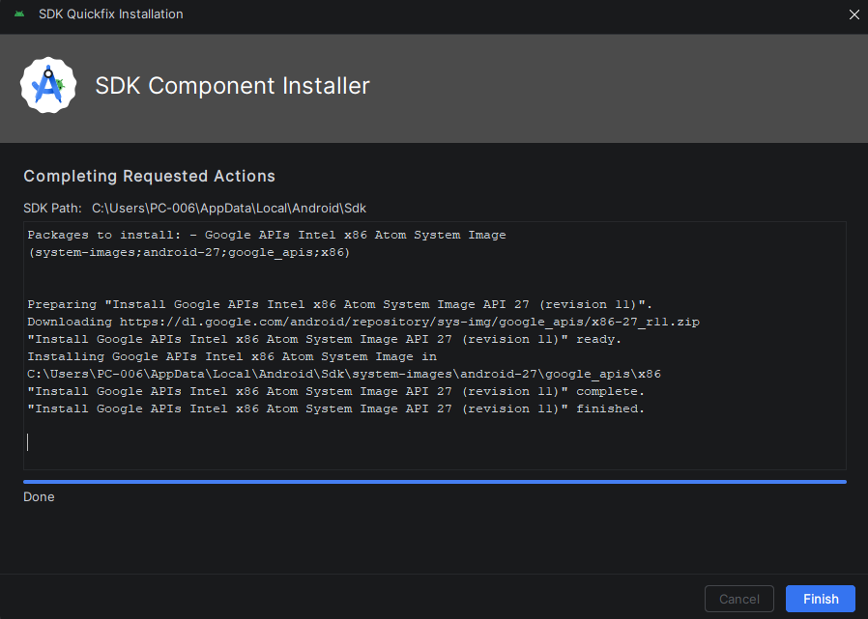
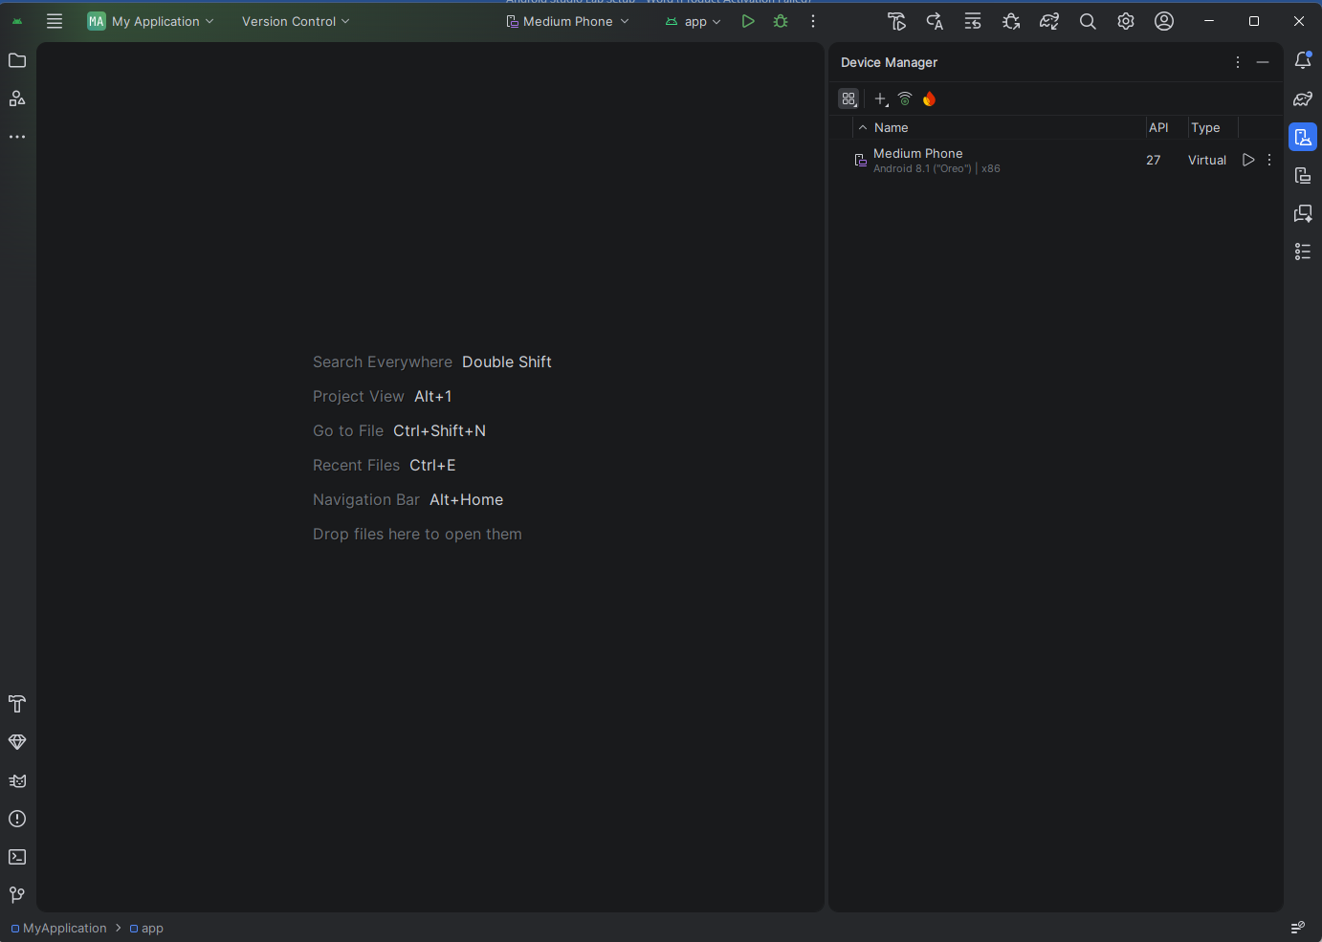
Click the play button will start the AVD.

